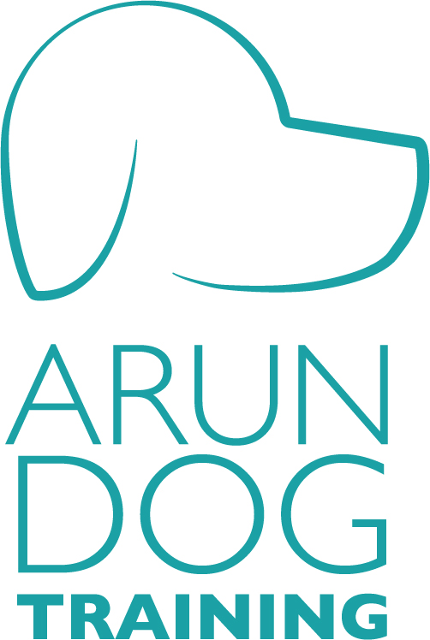

WHAT TO BRING – CHECKLIST
Hungry Dog: e.g. If your training session is in the morning only give a few pieces of food for breakfast.
Kibble: Please bring kibble, or equivalent, that is part of your dog’s daily food allowance. This will be used during training.
High Value Treats: Sausage, chicken, liver etc. Variety is good. Treats your dog absolutely loves! These should be chopped into small pieces (think pea-sized or less).
Toys: (if your dog enjoys play) - whatever you have that your dog likes to play with (tennis ball, rope, tug toy – best to avoid squeaky toys for class please).
Dog bed, mat or crate: To create a calm boundary space in the class. Doesn’t have to be fancy. A blanket, towel or veg box for a smaller dog will do.
Collar: A normal flat collar (no choke collars please).
If you already use a head collar (like Gentle Leader or Halti) you can bring it if you wish, but this is not necessary for all clients.
Lead: A standard lead or a double-ended lead (if you use one). No flexi-leads please as they are heavy and awkward to use for training classes.
Harness: If you haven’t got one already or were thinking of getting a new one at some point, we recommend getting a harness with a ring at the front and a ring on the back e.g. Xtradogs
Water Bowl: Training is thirsty work! We do not provide water bowls for health reasons.

